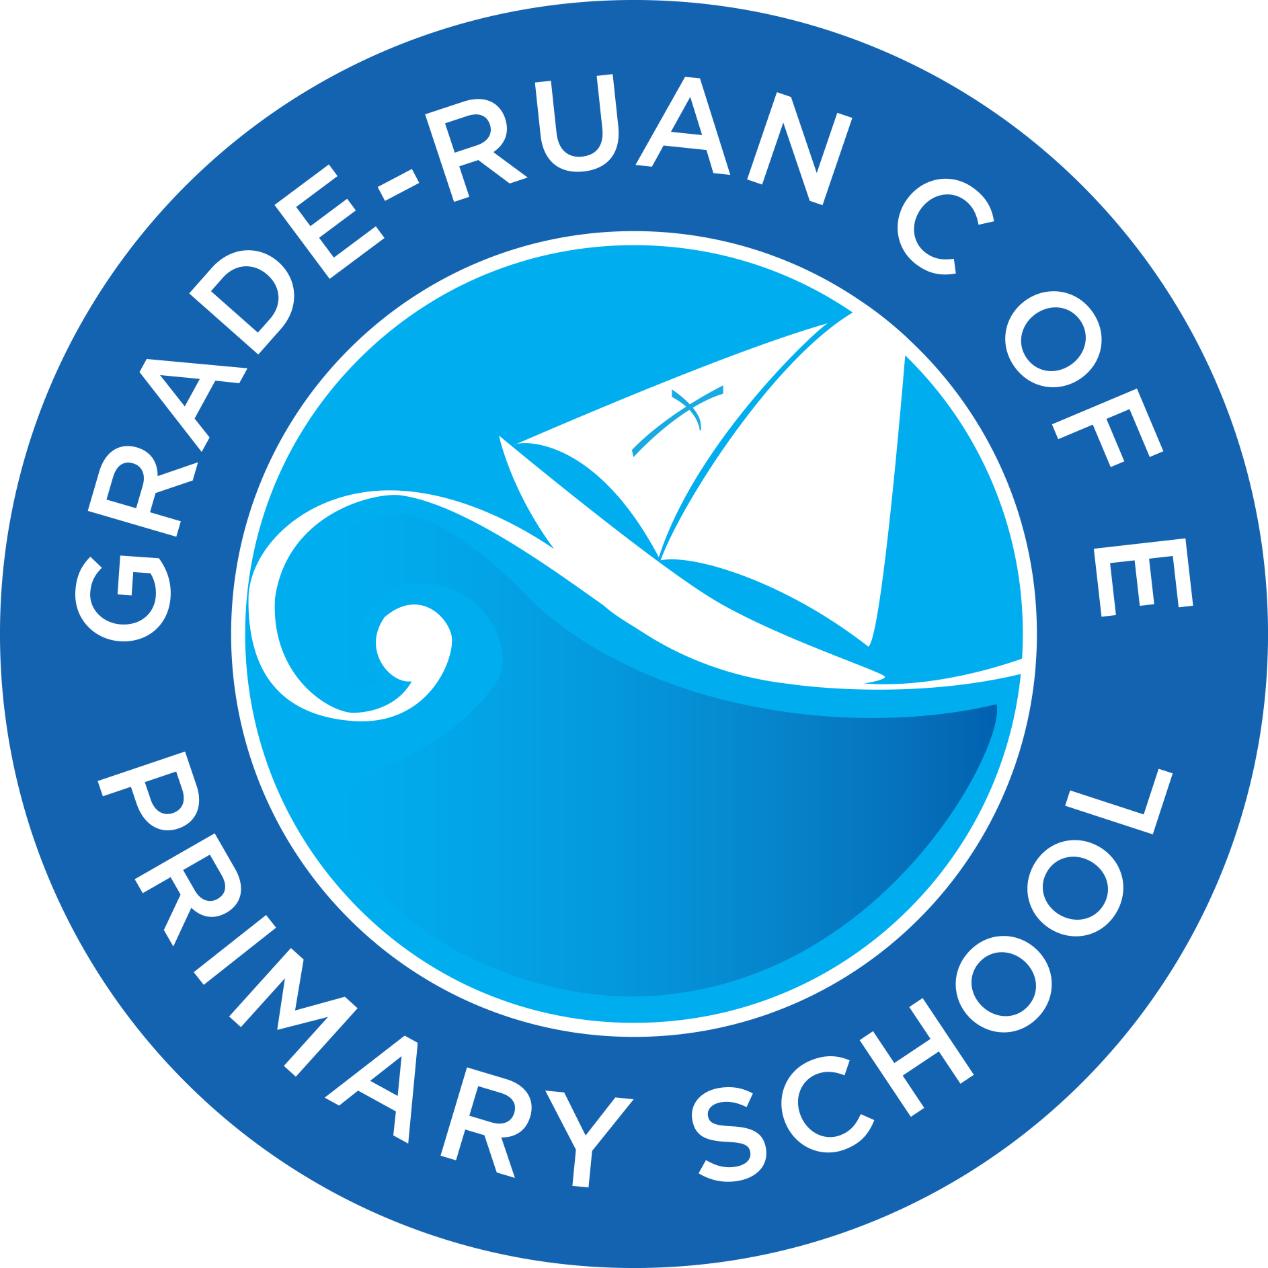 | Handwriting Policy  Developing confident, fluent writers  October 2025 - Updated October 2026
1. Introduction
At Grade Ruan C of E School, we believe that handwriting is a vital life skill that enables children to communicate effectively, express creativity, and take pride in their written work. Our handwriting policy provides a consistent, evidence-based approach to teaching handwriting across all year groups, with the aim that every pupil will develop a fluent, legible, and confident handwriting style.
This policy draws upon best practice from the National Handwriting Association’s “Developing a Handwriting Policy” and the Morrells Handwriting Policy (2025), aligning with the Department for Education’s Writing Framework.
2. Aims
Our aims are to ensure that all pupils:
- Develop a legible, fluent, and comfortable handwriting style that supports effective written communication.
- Achieve automaticity in handwriting, allowing focus on content rather than letter formation.
- Take pride in presentation across all subjects.
- Understand the importance of handwriting as a lifelong skill and a form of self-expression.
- Develop as hybrid writers, confidently using both handwriting and technology.
3. Rationale
Handwriting is not a natural skill; it must be explicitly taught and practised. Research shows that fluent handwriting supports spelling, composition, and overall literacy development. At Grade Ruan School, handwriting is taught systematically, beginning with early mark-making and progressing to fluent, joined writing by the end of Key Stage 2.
4. The six stages of writing progression
1. Foundation stage – readiness for writing
Children begin developing the gross and fine motor skills necessary for handwriting, including achieving a correct pencil grip and sitting posture. At this stage, they learn the correct size and direction of letters through early mark-making and guided practice of forming letters correctly.
2. Key Stage 1 – developing letter formation
Pupils continue to refine their letter formation, spacing and size. By the end of Year 2, more able pupils may begin learning and applying horizontal and vertical joins, laying the groundwork for joined handwriting.
3. Lower Key Stage 2 – introducing joins
Letter formation is further embedded, and pupils begin learning to join letters. This stage focuses on building fluency and consistency in the early stages of joined writing.
4. Middle Key Stage 2 – securing joins
Pupils consolidate their understanding of joins, working towards confident and automatic use of joined handwriting across subjects.
5. Upper Key Stage 2 – developing fluency and presentation
Children practise joined handwriting with a focus on speed, fluency, and presentation. They apply these skills consistently across all written work.
6. Upper Key Stage 2 – embedding legibility and style
Pupils refine their handwriting style, ensuring legibility, fluency, and appropriate presentation. Joined handwriting becomes a natural and efficient tool for written communication.

5. Teaching Approach
5.1 Early Years Foundation Stage (EYFS)
In Reception, handwriting begins through play-based learning and motor skill development. Children engage in activities that strengthen fine and gross motor control, spatial awareness, and coordination.
Key principles:
- Handwriting starts with play, not pencils.
- Activities include: painting, threading, building, cutting, and outdoor mark-making.
- Children are encouraged to draw, trace, and copy shapes before forming letters.
- Correct pencil grip and posture are modelled early.
- Letter formation is introduced through movement-based letter families
- Reminders on the correct process of handwriting are given using P-checks and S-factors act as a guide to our teaching of handwriting.

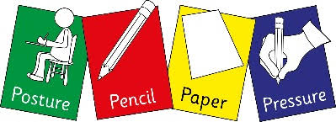

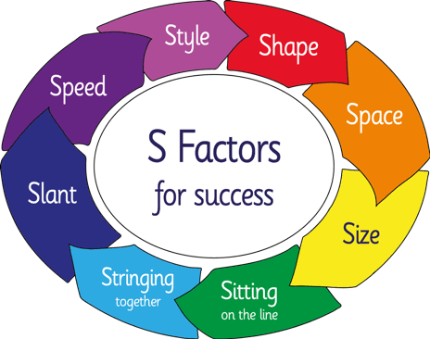

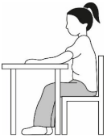
5.2 Key Stage 1
Children learn to:
- Sit correctly at a table with feet flat on the floor.
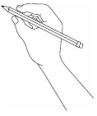
- Hold a pencil using a tripod grip.

- Hold the pencil 2 to 3 centimetres from the tip to see what they are writing more clearly and avoid smudging their work
- tilt the paper appropriately to the right or left and align the left edge with their left arm to maintain a natural wrist position, improve visibility and prevent a hooked grip
- move their whole arm across the page rather than twisting the wrist or fingers, which can cause discomfort and poor letter formation
- position their hand underneath the line
- Form lowercase and uppercase letters correctly, starting and finishing in the right place.
- Write on the line with appropriate spacing between words.
- Develop consistency in letter size and relative positioning (ascenders, descenders, x-height).
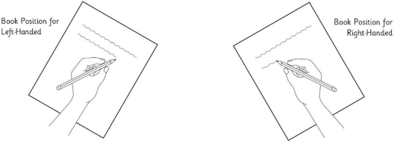
Teaching methods:
- Daily 10–15 minute handwriting sessions.
- Explicit modelling by teachers on boards and visualisers.
- Close observation of children’s handwriting techniques.
- Use of Morrells Handwriting resources and strengthening exercises.
- Positive reinforcement and immediate feedback.
5.3 Key Stage 2
Children consolidate and refine their handwriting skills:
- Transition from print to joined handwriting when letter formation is secure.
- Develop fluency, speed, and legibility across all subjects.
- Learn to adapt handwriting for different purposes (e.g., note-taking, formal writing, diagrams).
- Continue to practise correct posture, grip, and paper position.
By Year 6, pupils should:
- Write fluently and legibly at speed.
- Demonstrate pride in presentation.
- Choose the most appropriate writing implement for the task.

Teaching methods:
- Daily 10–15 minute handwriting sessions.
- Explicit modelling by teachers on flip chart with Morrells paper
- Close observation of children’s handwriting techniques.
- Use of Morrells Handwriting resources and strengthening exercises.
- Positive reinforcement and immediate feedback using P-checks and S-factors
6. The Grade Ruan Handwriting Style
Grade Ruan School uses a simple modern cursive style based on the Sassoon Primary font, which supports clear letter formation and smooth progression to joining.
Handwriting families (movement-based):

Children are taught to form each letter correctly before learning to join. Joining is introduced gradually in lower Key Stage 2 once fluency and control are established.
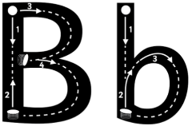
The Morrells resources use visual cues to assist the writer with letter direction:
• dots for starting points
• arrows for direction with a "bounce" symbol to show return strokes
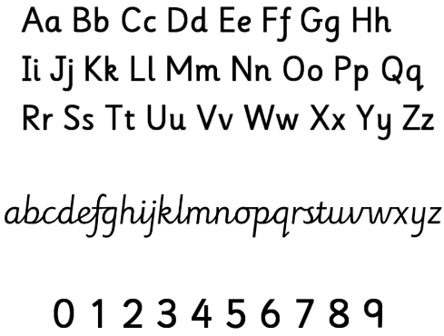
7. The P Checks – Setting Up to Succeed
To ensure success, teachers and pupils regularly review the P Checks (from the NHA framework):
- Posture: Sit upright, feet flat, back supported.
- Pencil: Use a tripod grip, holding the pencil 2cm from the tip.
- Paper: Slanted slightly to the right (or left for left-handers).
- Pressure: Apply moderate pressure for smooth, rhythmic writing.

8. Provision for Left-Handed Pupils
Left-handed pupils receive specific guidance to ensure comfort and legibility:
- Paper tilted to the right, aligned with the left arm.
- Pencil held 2–3cm from the tip to avoid smudging.
- Seated on the left of right-handed peers to prevent bumping elbows.
- Use of soft pencils and fast-drying pens.

9. Inclusion and Support
We recognise that some pupils may experience handwriting difficulties due to motor, perceptual, or cognitive challenges.
Support strategies include:
- Fine motor skill activities (e.g., threading, pegboards, playdough).
- Use of adaptive tools (e.g., pencil grips, sloped boards, textured paper).
- Short, frequent practice sessions.
- Collaboration with the SENCO.
- Use of assistive technology when appropriate.

10. Assessment and Monitoring
- Teachers assess handwriting formatively through observation and written work.
- Pupils self-assess using the S Factors (Shape, Space, Size, Sitting, Stringing, Speed, Style).
- Progress is reviewed during book looks and moderation meetings.

11. Resources
- Morrells Handwriting Workbooks (EYFS–KS2)
- Morrells flipchart paper for modelling
- Sassoon Primary font for classroom displays and resources
- Pencil grips, and ergonomic pens as needed
- Wide-lined paper for early writers, narrowing as fluency develops
- Posters displaying letter formation, P-checks and S-factors

12. Handwriting and Technology
At Grade Ruan, we value both handwriting and digital literacy. Pupils are encouraged to:
- Use handwriting for creative, expressive tasks and extended writing.
- Use technology for research.
- Practise touch typing as a complementary skill.

13. Roles and Responsibilities
- Teachers: Model correct handwriting, provide explicit instruction, and monitor progress.
- Pupils: Take pride in presentation and practise regularly.
- Parents/Carers: Support handwriting practice at home using school guidance.
- Leadership Team: Review policy implementation and ensure staff training.

14. Review and Evaluation
This policy will be reviewed annually by the English Lead and Senior Leadership Team to ensure alignment with current research and national guidance.

