

Grade Ruan C of E School Expectations and Systems
Our School Rules: ‘The Grade Ruan Way’
- RESPECT - Be respectful
- RELATIONSHIPS - Be a good friend
- WISDOM - Be wise
- ASPIRATION - Be aspirational
We define these rules as our ’Keys to Success’. They are based on our four core Christian values, ‘the keys,’ and clearly define The Grade Ruan Way of high standards of behaviour and a positive ethos, embedded in our school vision:
Setting sail on life’s journey, with an anchor to keep us safe, sails to let us fly and God to calm the storms along the way.
RESPECT | RELATIONSHIPS | WISDOM | ASPIRATION
"Care for Our Crew & Waters!!  We listen politely, treat everyone with kindness and respect and look after our school. | "All in the Same Boat!"  Work together as a supportive crew, include others in play, and celebrate friends' successes. | “Navigate with Thought and Care!"  Make safe choices, ask curious questions, and learn from mistakes. | "Set Sail for High Horizons!"  Aim high, persevere through tricky tasks, take pride in learning and never give up when the waves get rough.

These are the expected behaviours we would see following our 4 rules:
Respect | Relationships | Wisdom | Aspiration
Are you...  - Polite and respectful at all times?  - Greeting people politely and being helpful?  - Taking pride in yourself and our school?  - Listening to others?  - Coming to school on time? | Are you...  - Being kind and helpful?  - Being honest?  - Valuing others’ opinion?  - Enabling everyone to learn?  - Using kind hands and feet? | Are you...  - Making the right, wise choices?  - Keeping yourself and others safe?  - Using your time wisely?  - Using technology responsibly?  - Talking to an adult when something is wrong? | Are you...  - Eager to learn?  - Following instructions the first time?  - Demonstrating a positive mindset?  - Aiming to be the very best you can be?  - Are you ready to learn and set sail?
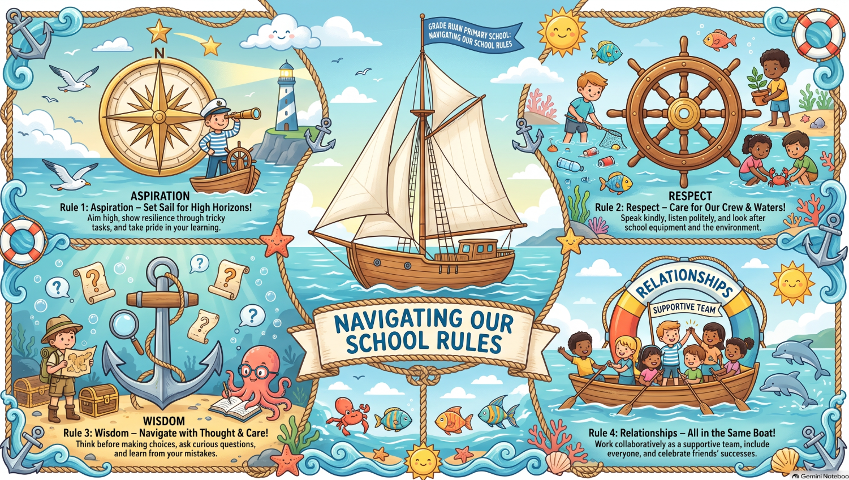

Precise Routines which are used at Grade Ruan School:

Transitioning at Grade Ruan C of E School
 | Entering the school: all children are greeted on the main gate by a member of staff.  KS2: Children enter through playground main gate, walk up the ramp to the Elliot building door where an adult greets them. They leave coats and bags in the cloakroom and go into class with their water bottle and reading book. They sit quietly at their desk and read, whilst being registered.  EYFS and KS1: Children enter through playground main gate, through the Rose Class outdoor provision area and into the classroom via classroom door where an adult will greet them. They leave their coats in the cloakroom and then sit on the classroom carpet for registration.  *pre-agreed families and children may use the main reception door. In some cases, this is part of the children’s provision  Moving around school:  Pupils are expected to line up quietly and walk around the school in single file, keeping to the left in corridors and on steps.  Transitioning to and from the start and end of lunch/ break:  KS2:  Break: Children released in year groups so as not to clog up the cloakroom. They quietly get coats and snacks and leave via classroom steps. After break, the children line up, single file, in the playground.  Lunch: Children are asked to stand behind chairs before they can leave the room. They wash their hands, get their lunches from the cloakroom and walk quietly to the hall. Children queue quietly for their lunch when called up.  EYFS and KS1:  Break: Children line up by the classroom outside door one at a time to go outside and exit in single file through the outdoor provision.  After break they line up in the playground, single file, ready to come in.  Lunch: One at a time children wash their hands and return to line up in the classroom. An adult will take the children from the classroom into the hall. Children queue quietly when called up for their lunch.
At the end of lunch, classes stop on the first whistle and line up silently in classes in the playground on the second whistle before being led into class by their teacher.

Collective Worship: Children in KS2 line up at the door and a monitor will encourage children to move quietly. Children stay to the left. The Worship Leaders will have set up the hall for the collective worship. KS1 come directly from their classroom quietly with an adult leading.

 | Gaining pupils attention at Grade Ruan C of E School
  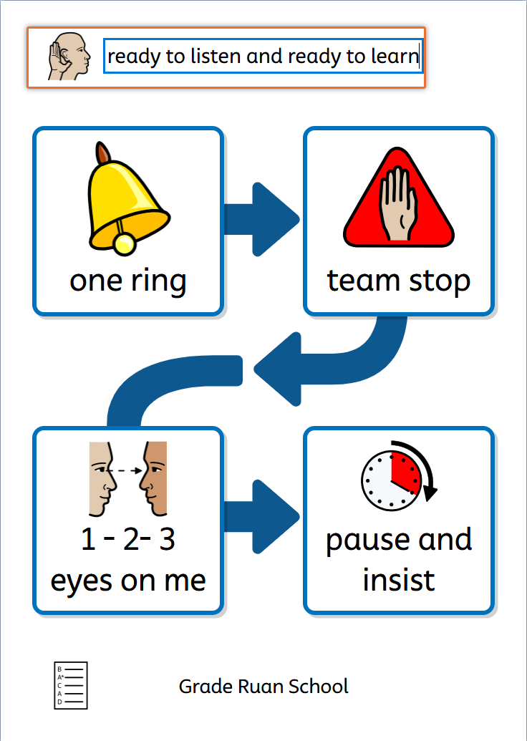 | The approach to gaining a pupils attention is:  SIGNAL – PAUSE - INSIST  An adult rings a bell once and raises their hand, showing the palm of the hand. They track the children with their eyes and wait for silence from all pupils before continuing.  Pupils move from the carpet to their tables on a 1-2-3 instruction.  Children are praised for tracking the teacher and demonstrating ‘Listening Bodies’ and ‘Learning Bodies’.
 | Clear and consistent expectations at Grade Ruan C of E School
 | - Tidy tables, tidy minds  - Classrooms should be tidy and well presented.  - Displays and boarders should be consistently maintained.  - On pupil’s tables there should only be equipment that they need.  - When leaving the classroom, tables should be orderly, the floor clear of any mess and chairs tucked in.  - Unless there is a prior agreement with the class teacher or SENDCO, children should not be fiddling with anything at any point.  - All pupils should have removed any items not deemed school uniform in the classroom (hats, scarfs, gloves, ear muffs, bracelets, rings) unless it is part of an agreed plan.  - Children should be consistently demonstrating that they are ready to learn and showing respect towards staff and their peers.  - Whilst the teacher is talking there should be no talking from any member of the class.  - The behaviour support policy will be adhered to consistently.
 | Work expectations at Grade Ruan C of E School
 | Noise level: Pupils should be expected to work within the expectation of the class staff which will depend on the task given.  We encourage pupils to use ‘indoor voices’ during lessons but also to understand that there are times when silent working is necessary.  Different Situations:  - Independent working  - Pair / share talk  - Group work  - Whole class discussion
Classrooms Routines | - Pupils will arrive by 8:45am and wearing correct school uniform.  - Children to enter the room at all times, quietly.  - Pupils sit on a chair with all 4 legs on the floor, chairs are tucked in with approximately a fists gap between their chest and the table. Children will endeavour to sit up straight. We call this listening and learning bodies.  - Answering questions will require a range of strategies: some questions will be answered on whiteboards (adults will say ‘1, 2, 3 – show’. Cold Calling may be used and at all other times pupils will raise their thumb.  - Pupils may be asked to speak to their partner for a period of time. They will be asked to ‘talk to your partner.’  - All adults will use the ‘Signal, Pause, Insist’ routine to gain pupils attention, as above. The teacher will track the class and all pupils are expected to follow this before progressing.  - Pupils will begin work immediately after the teacher sets them off on their task. Pupils will work quietly and purposefully unless advised otherwise.  - Toilet passes will be used in class and only 1 boy or girl can leave the class although there are no restrictions on the number of times.  - Yellow lanyards are used for classroom passes if a child needs to leave at anytime.  - Pupils will leave the room quietly, until they reach the playground or their destination.
Dinner Hall Routines | - Pupils enter the hall quietly.  - Pupils sit at their table with their peers until they are called to collect their dinner. Voices should be at a talking level and not a shout.  - Polite manners are used towards lunchtime staff.  - All cutlery and plates are returned to the wash station and pupils exit the hall quietly when it is time to leave.

Reward Toolkit:
Name of the reward | Why is the reward given? | When is the reward given? | Who gives the reward?
Star Sailor | Academic  attainment, effort or progress in English and Maths; making the right choices. | Certificate given to child at the end of the school day. | Chosen by class teachers.
Star of the week | Overall Recognition | Certificate given to child in celebration assemblies. | Chosen by class teachers and shared in Celebration Assembly.

In-Class Reward Systems;
‘Setting Sail Chart’
Within each class the below scale will be displayed. All children will start on ‘Ready to Learn’ at the beginning of the day. Dependent upon behaviours they will move left or right.
Time to turn it around! | Think about it! | Ready to learn! | Setting Sail! | Role Model! | Star Sailor!
Reflect!  We can turn this around and get you back on track.  Name maybe removed from board. | Refocus!  Time in to repair and reflect with the class teacher. | We are ready to sail….!  All start here everyday | Well done!  You are sailing in the right direction! | Great!  You’ve been recognised for making all the right choices! | Amazing!  You’ve earned star sailor recognition!
Help me understand…  What happened…  I wonder what you were thinking/ feeling at the time…  I imagine that was…  I imagine you felt…  I wonder how this might…  I wonder what we could do…  What I’m noticing is that when x happens you do x… | Regulate: take some time to calm down  Reflect: what went wrong? What can I do differently?  Act: now it’s time to do it and get back to green
Physical or verbal aggression to others or  directed towards the environment  Leaving the classroom | Leaving seat repeatedly  Disrupting the learning of others  Shouting out, | Ready  Respectful  Safe | Showing consideration and support for others,  Seeking support appropriately  Consistent effort, | Exceeding expectations of learning  Persevering when learning is challenging | Showing behaviour that is continually above  and beyond the expectation  Consistently being in
without permission  Any behaviour that compromises the safety of others within the classroom  Bad language  Mobile phones out in class | interrupting the calm  environment of the class  Disengagement with own learning |  | attention and concentration | Demonstrating care and concern for others | the right place, at the  right time, doing the right thing

Other rewards include:
  - Giving praise, both verbal and written
  - Sharing and making an example of good behaviour
  - Positive feedback to parents/carers

General rewards for individuals who manage to consistently meet our high expectation:
  - Quiet word of personal praise.
  - Public recognition in class or assembly.
  - Sending good work to a senior leader
Sanctions
Sanctions Overview:
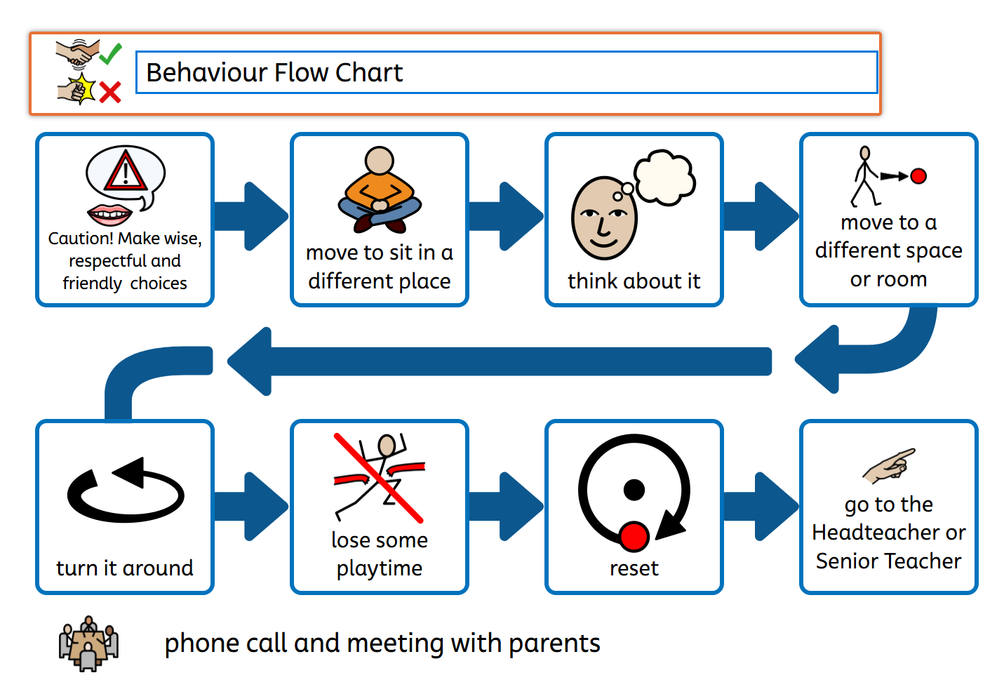

  - Pupils will have 2 warnings before a sanction is given. Firstly a verbal warning and a reminder to make the right choices. A change of seat within the classroom may help. Followed by the movement of their name to ‘Think about it’. At this point the child can ‘Turn it around’ and change their behaviour without loss of break time.
  - If a child continues to make the incorrect choices they must miss a maximum of 5 minutes of their break and be given the opportunity to ‘Reset’.
  - Teachers will be responsible for supervising the loss of break time.
  - If pupils reach the ‘Turn it around’ phase 2 times in a week, a conversation with a parent/carer will take place.
  - Pupils that have persistent behaviours of concern over a 4- week period will have a Positive Behaviour Support Plan which will detail an individualised approach to their behaviour support.

Sanctions Pathway:
Steps |  | Action
1 | Redirection | Non-verbal cues or a gentle encouragement to change the unwanted behaviour to one that we expect to see.  For example: “Well done to this table, you are listening and ready to learn. I can see that almost everyone is ready” At this point, pause and wait before continuing.  If the behaviour continues move to step 2.
2 | Reminder. | A reminder of the expectations ‘Make wise choices’ delivered privately wherever possible. Repeat reminders if necessary. Continue to frame all language positively – “Remember, being respectful means look at and listening to the adult whilst waiting your turn to talk, thank you.”  If the behaviour continues move to step 3.
3 | Caution | A clear verbal caution delivered privately wherever possible, making the learner aware of their behaviour. Clearly outlining the consequences if they continue but making it clear as to how they can turn this around. E.g. “What can I do to help you? Help me to remember what you should be doing right now?”
4 | Time with/Missed playtime | Pupil will spend time with the class teacher for 5 minutes at a break or lunch period.  It is imperative that this is conducted with the class teacher or HOS and that the focus of the discussion is centred around the pupil understanding the behaviour displayed, the consequence and then how they reset their behaviours ready for the next period of learning.  If the behaviour continues move to step 5
5 | Escalation to HOS | Should the learner persist with the unwanted behaviour or if the same pupil has had ‘time with’. The HOS will be notified and a phone call home to is to be made to make parents/carers aware of the behaviours being seen at school. These behaviours should be logged in MyConcern or using ABC/behaviour log sheets. HOS involved.
6 | Formal  Meeting | A meeting with the pupil, parents, teacher, SENDCo and Head of School to take place and recorded on MyConcern if there is no noticeable change in behaviour after the phone call home or the child has had 4 or more ‘time with’ in 1 week.
Exception  Immediate response |  | When certain gross misbehaviour has occurred towards pupils and adults, an immediate response is necessary, such as:-  - Serious fighting  - Bullying  - Derogatory behaviour such as racist, homophobic or non-inclusive  - Bad language directed at an adult  - Defiance  - Damaging property  - Hurting others with deliberate intent  In these cases, the incident will immediately be reported to HOS and recorded/logged, and an appropriate sanction/action taken in consultation with HOS. A phone call home by a member of HOS will automatically take place. The behaviours will be explored and managed by the school’s leadership team, class teacher and SENDCo.

Sanction pathway for break and lunch periods:
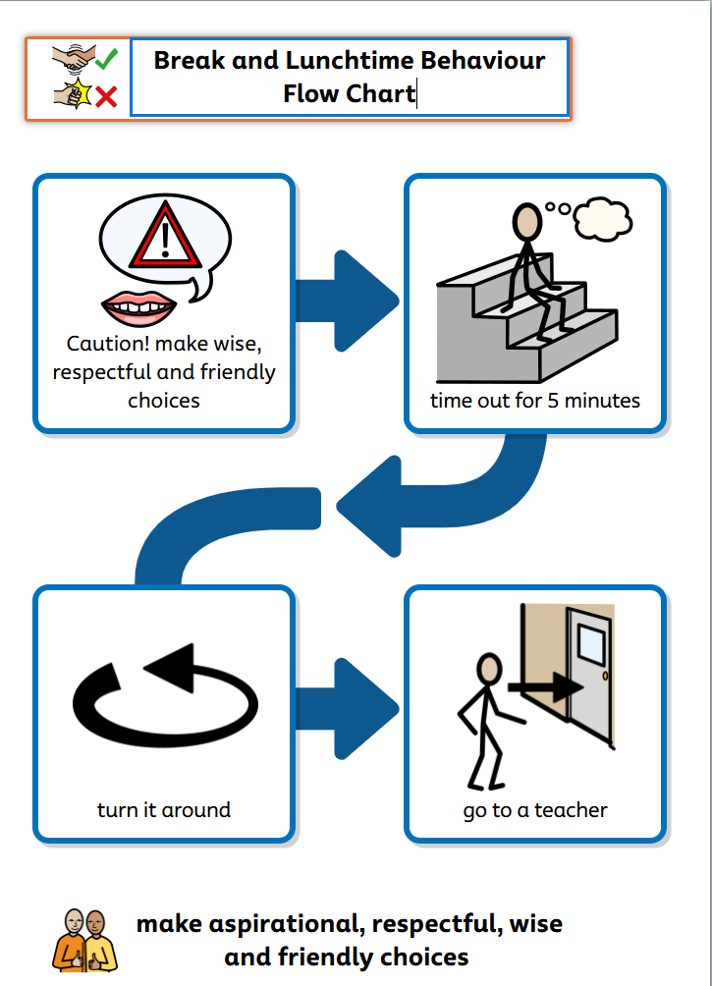
  - Pupils are expected to follow the school rules during break times and lunch times also.
  - 1 quiet verbal warning.
  - A second one might be given to remind of expectations
  - If behaviours persist, the pupil will need to take time out and sit or walk and talk with the adult on duty for 5 minutes to reflect and ‘turn it around’.
  - For significant incidents, a member of the teaching team will be called to support or the child will have to go inside to sit with a teacher.
Approaches taken for repair/restorative conversations:
These are to take place following an incident. This is to be conducted by the class teacher/ person leading the session. It should be a coaching conversation for the pupil. The structure for the conversations is:
  - Ask what happened
  - Ask the pupil who they think was affected by their behaviour
  - Ask them what they could have been done differently and what they would do to avoid the situation happening again.
  - Ask what the adult/other child could have done differently and what they could do differently next time to support.
  - Agree strategies/goals/targets for the future
  - Give the child a chance to add anything else they wish. Do not force an apology – it will not improve the situation (however acknowledge those freely given appropriately).
  - In KS2, this process may be physically recorded by the pupil and adult.

