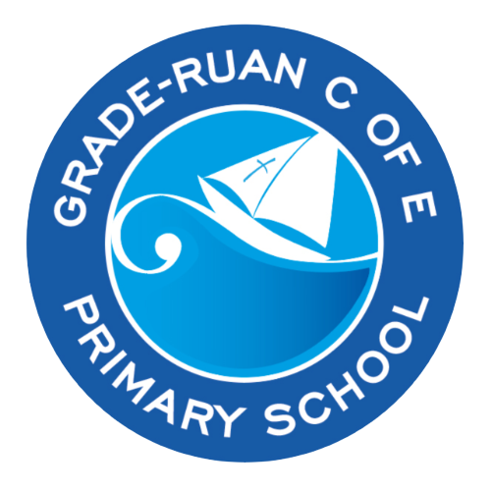 | Music development plan summary: Grade Ruan C of E Primary School

Overview
Detail | Information
Academic year that this summary covers | 2025-2026
Date this summary was published | September 2025
Date this summary will be reviewed | July 2026
Name of the school music lead | Esther Bosustow
Name of school leadership team member with responsibility for music (if different)
Name of local music hub | Asone Hub
Name of other music education organisation(s) (if partnership in place) | Cornwall Music Service Trust

This is a summary of how our school delivers music education to all our pupils across three areas – curriculum music, co-curricular provision and musical experiences – and what changes we are planning in future years. This information is to help pupils and parents or carers understand what our school offers and who we work with to support our pupils’ music education.

Part A: Curriculum music
This is about what we teach in lesson time, how much time is spent teaching music and any music qualifications or awards that pupils can achieve.
At Grade Ruan C of E School, we aim for all children’s education to be enriched by music.
All children have a weekly music lesson of at least half an hour. There is also a 20-minute singing worship each week, as well as in class rehearsal of the songs they are learning. Children in KS2 (Key Stage 2) also use Charanga for individual practice. As part of our computing curriculum, children also learn to compose music using Scratch.
In Reception, the children sing songs and rhymes daily. Games and activities which promote a sense of pulse, rhythm and pitch are regularly used. There is a music area in the outside provision. The children have a chance to perform songs for festivals and special occasions plus termly ‘sing-along’ events for parents and carers.
In KS1 (Key Stage 1) and KS2 our curriculum meets the requirements of the Model Music Curriculum (MMC) through the adoption of the Charanga on-line Music Scheme. This music scheme is delivered in Key stages 1 and 2 by the class teachers. In KS1, children are taught to sing in unison, appraise a wide range of music and read, play, compose and improvise music on glockenspiels, as well as a variety of unpitched instruments. In KS2, children learn to sing and play their instruments in parts, with an awareness of their audience, as well as developing their understanding of a wide range of music from different times and places. They build confidence in composing and improvisation. The children perform songs for festivals and special occasions plus termly ‘sing-along’ events for parents and carers.
In addition to this, in lower key stage 2, children learn an instrument as a whole class in conjunction with Cornwall Music Service Trust. Some children may continue with these instruments in small groups or one-to-one.
Supporting SEND (Special Educational Needs and Disabilities) in music
Charanga also has a range of SEND resources and apps including their units ‘Anyone Can Play’ and several signed songs. These are available for any children where it helps them to access the music curriculum. Instrumental parts can be adapted to ensure they are at the right level for each student.
Other provisions made for SEND children to ensure an inclusive curriculum are the use of ear defenders, smaller group work, separate spaces, differentiated learning (e.g. simplified rhythms or melodies), individual tuition and alternative instruments or equipment where a disability may prevent inclusion e.g. Buzz instead of trumpet or kazoo instead of recorder.
You can find more detailed information about our music curriculum here:
https://www.graderuan.org/web/music/628545

Part B: Co-curricular music
This is about opportunities for pupils to sing and play music, outside of lesson time, including choirs, ensembles and bands, and how pupils can make progress in music beyond the core curriculum.
In conjunction with Cornwall Music Service Trust, children can receive lessons in guitar, piano / keyboard, woodwind and brass. Pupil Premium children can receive these lessons without charge. Children learning instruments, once at a certain level, are encouraged to perform to their class, to the school or even in community events, such as the annual Summer Spectacular.
Pupils at Grade Ruan who love to sing, have the opportunity to join the choir, which is open to children in KS2. This is led by the music lead. As well as performing regularly at school events such as the Christmas Church Service, the choir take part in SongFest, ChoirFest (in conjunction with ASONE hub) and perform regularly in the community. This is a real highlight for all involved as the children get to perform with a live band as well as experience singing in a large, professional theatre. At SongFest, they also have a chance to sing with other schools to create a massed vocal ensemble of over 200 voices.
Songs for our weekly singing worship have been carefully chosen to not only reflect the school’s values but also to promote diversity. Songs from a wide variety of cultures and traditions are used. Creating a culture where all music is celebrated and respected encourages learners to be confident in enjoying, embracing, and sharing the music that is meaningful to them.
We also aim to take different year groups each year to the Hubbub, a multi-workshop experience where children can try out a range of different musical activities. This is organised by the ASONE hub.

Part C: Musical experiences
This is about all the other musical events and opportunities that we organise, such as singing in assembly, concerts and shows, and trips to professional concerts.
There are regular opportunities throughout the year for the children to have musical experiences.
- Weekly singing worship
- SongFest
- ChoirFest
- Cornwall Hubbub
- Christmas Production
- Harvest Festival
- Easter / Christmas / Leaver’s Services in our Church
- Summer Spectacular
- In class informal performances by children
- Performances by visiting musicians

In the future
This is about what the school is planning for subsequent years.
We have 3 areas of music that we aim to develop.
- Development of Early Years music in conjunction with Cornwall Music Service trust.
- Enhance provision for instrumental lessons to increase the number of children learning an instrument, to increase the profile of instrumentalists and to offer more opportunities for small ensemble playing.
- To foster a relationship with Mullion School to use facilities or take part in a transition project.

Further information
Useful Links for Parents and Carers:
Guide for parents from Department for education https://www.gov.uk/government/publications/music-education-information-for-parents-and-young-people
Cornwall Music Service Trust https://cmst.co.uk/news
ASONE Hub https://asoneperform.com/ and its local plan for music education https://asoneperform.com/news/1775026
About Charanga https://charanga.com/site/about-charanga/

