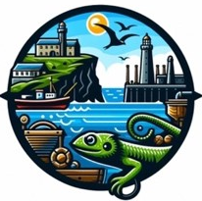
Grade Ruan School
Lizard Schools Science Curriculum

We are committed to providing a curriculum that is underpinned by three essential drivers: aspiration, curiosity, and diversity. We aim to empower our learners to develop the knowledge, skills, and values they need to not only succeed in their education but also to become successful global citizens. Through our rigorously and consciously crafted curriculum, we teach clear sequences of enquiry-based learning encompassing the National Curriculum, reflecting the unique and special part of the world in which we live. We believe in helping our children flourish, realising their full potential, and fostering a caring and nurturing community where every child is valued.
Our Science Concepts
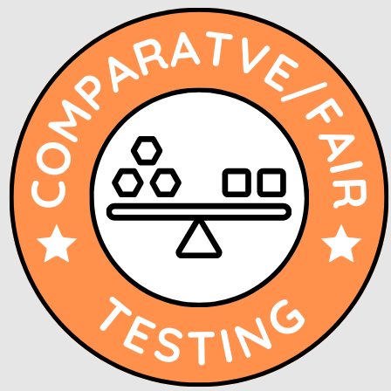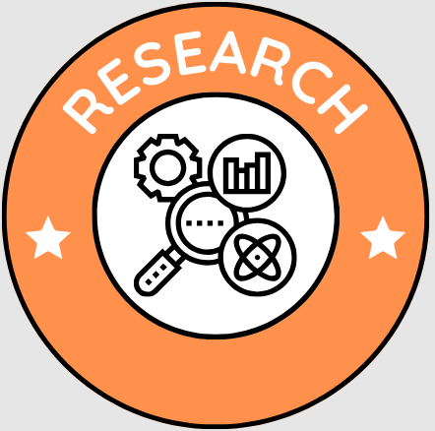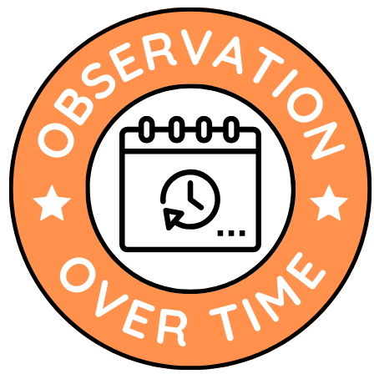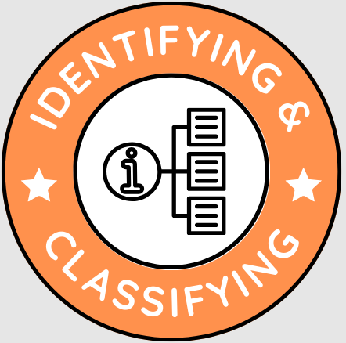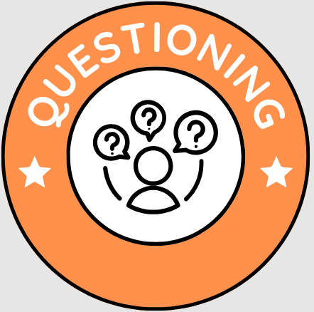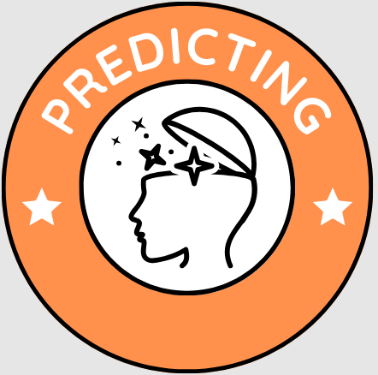
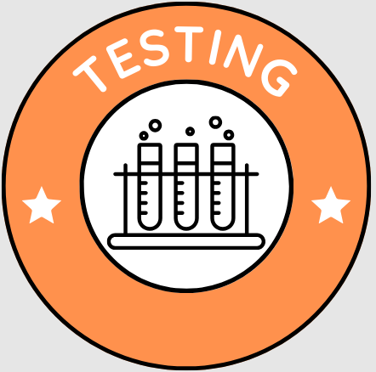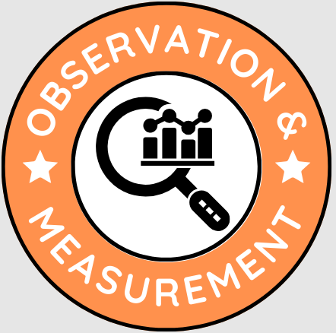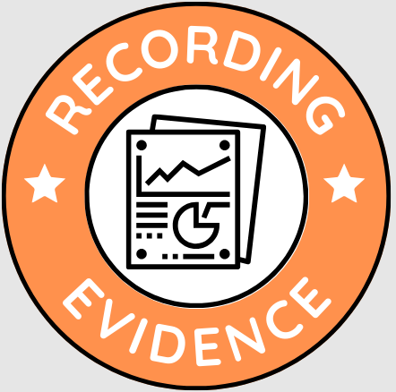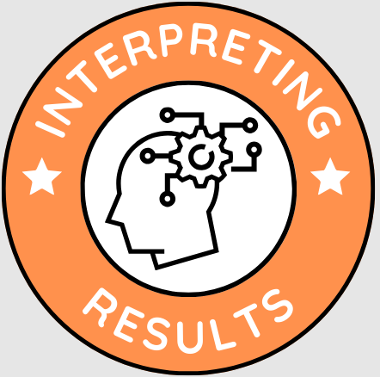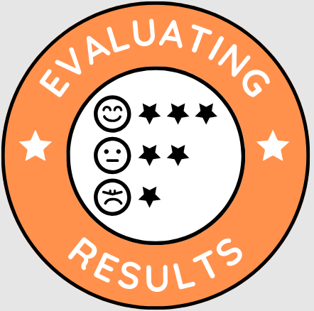

Curriculum Overview
EYFS CYCLE 1
AUTUMN | SPRING | SUMMER
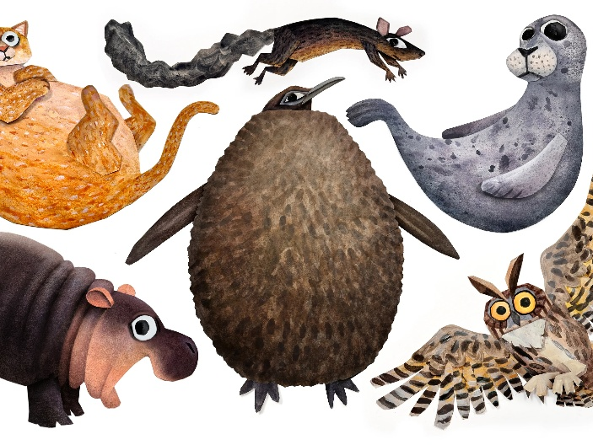  EYFS - Animals  Name different animals.  Know where different animals live.  Know what animals need to survive.  Compare animals. | 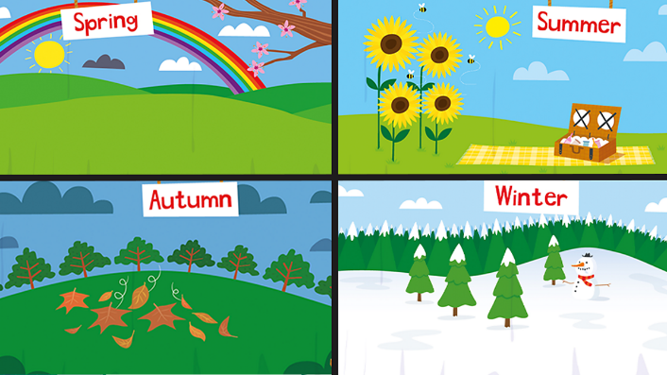  Seasons  Understand some of the changes we can see in the natural world and the differences in the seasons and weather.  Explore the impact of the weather and seasons on their day to day life. | 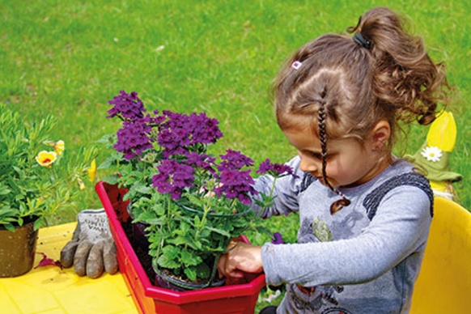  Plants  Know that plants are living things.  Explore plants around them.  Plant and grow their own plants.

EYFS CYCLE 2
AUTUMN | SPRING | SUMMER
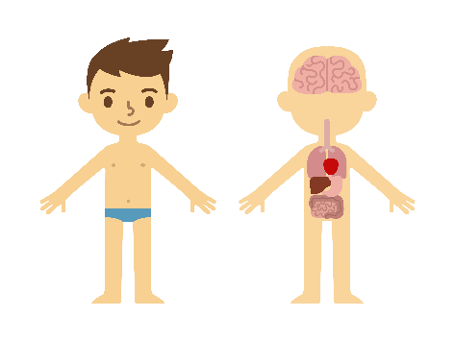  Our Body  Explore the body, learning the names and  functions of the main body parts.  Discuss how the body changes as they  grow and how we need a healthy diet.  Explore similarities between themselves and  others and how they are all unique. | .  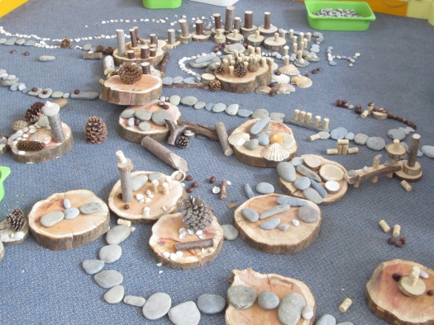  Materials  Know what is living and not living.  Know that some materials can change  shape.  Explore and understand what ‘waterproof’  means.  Explore materials that float and sink. | 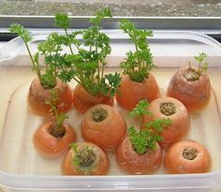  Growing  Know what plants need to grow.  Plant and grow their own plants.  Observe plants growing and changing over time.  Know the life cycle of a plant.

Key Stage 1 CYCLE 1
AUTUMN | SPRING | SUMMER
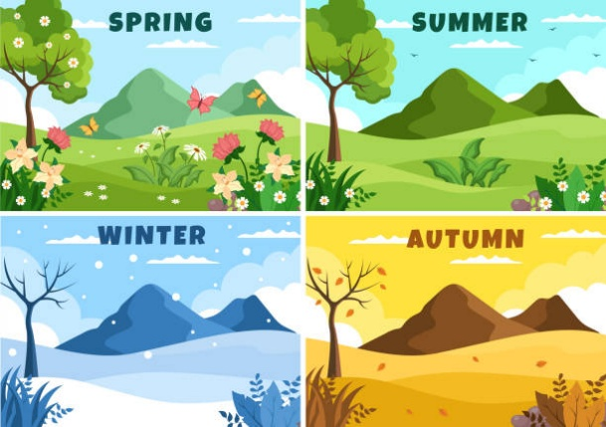  Why do seasons change (Autumn / Winter)?  Note, seasonal changes discussed throughout the year and through CP  1. What are signs of Autumn?  2. What is the weather like in Autumn?  3. What are signs of Winter?  4. What is the weather like in winter?  5. What happens to the day length in winter?  6. Why do seasons change? | 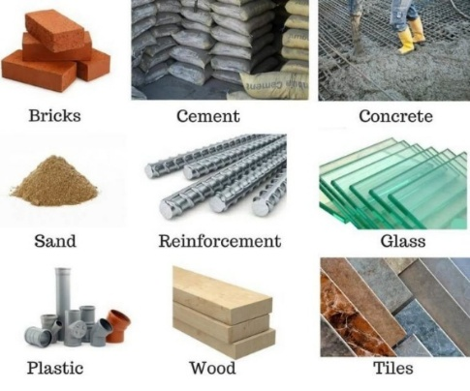  What material would be good for an umbrella??  1. What are materials?  2. How are materials di­fferent?  3. What are the properties of materials?  4. How can we sort materials?  4. How can materials change shape?  5. Why do we use different materials for different things?  6. Which material would be best for an umbrella? | 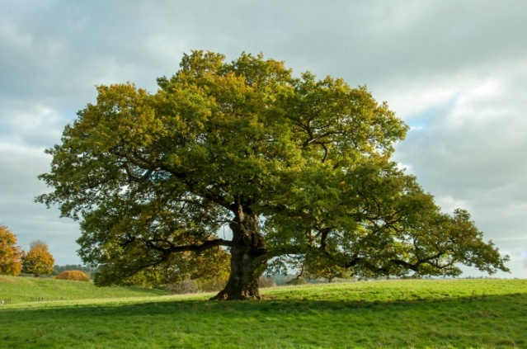  How can we identify different plants and trees?  1.What is a plant?  2. How can we grow a broad bean?  3. What are the parts of a plant called?  4. Are all plants the same?  5. Are trees a type of plant?  6. How can we identify different plants and trees?
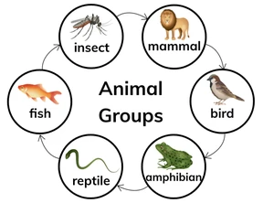  How can we group animals?  - How are animals different?  - Can we identify different animal groups?  - Can we identify the differences between amphibians, reptiles and fish?  - Do all animals eat the same thing?  - What is a food chain?  - How can we group animals? | 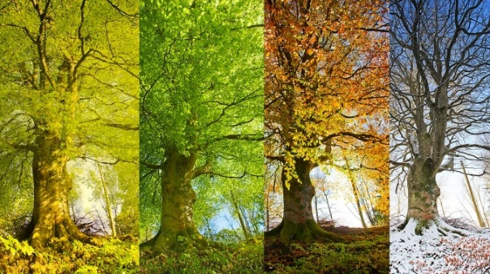  What happens when the seasons change? (Spring / Summer)  - What are signs of Spring?  - What is the weather like in Spring?  - What are signs of Summer?  - What is the weather like in Summer?  - Why do the days get longer in Summer?  - What happens when the seasons change? | 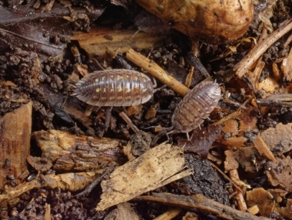  How are living things adapted to their habitat?  - Is it living, dead or never been alive?  - What is a microhabitat?  - How are habitats different around the world?  - What conditions do woodlice prefer?  - Can we design a suitable micro-habitat where living things could survive?  - How are living things adapted to their habitat?

Key Stage 1 CYCLE 2
AUTUMN | SPRING | SUMMER
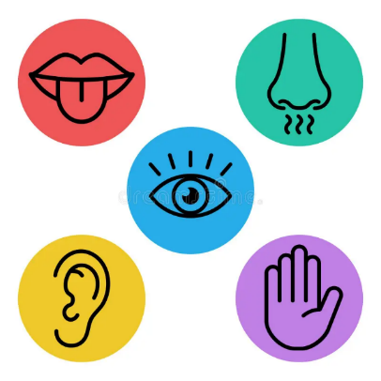  Can we name the parts of our body and describe our senses?  - Can we identify some of the parts of the human body?  - What can we learn about our ears and hearing?  3. Can we explore our tongue and taste?  4. Can we explore our sense of touch?  5. How does our nose smell?  - Can we name the parts of our body and describe each of the five senses? | 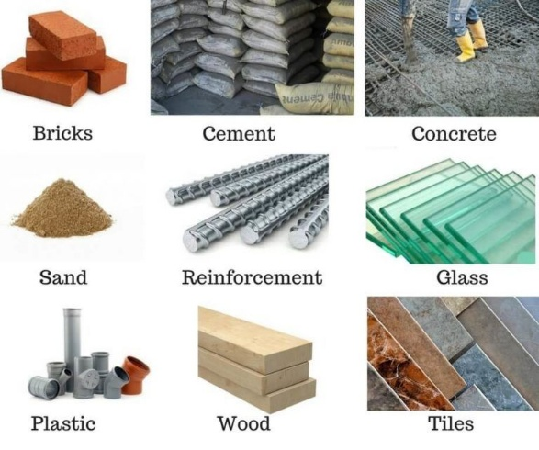  Which material is best to make a boat?  1. Can we identify and name a variety of different everyday materials ?  2. Why are things made from different materials?  3. Can we change materials?  4. Which materials float and sink?  5. Does a boat need to be waterproof?  6. Which material is best to make a boat? | 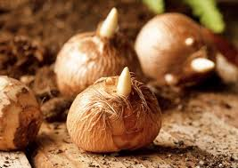  How do seeds and bulbs grow into healthy plants?  - Which plants can we eat?  - Are all seeds the same?  - What do seeds and bulbs need to grow?  - How and why do seeds disperse?  - Where will plants grow best?  - How do plants grow and change?  - How do we grow cress?  - Can we observe changes to our cress seeds?  - Describe the life-cycle of a plant  - How do seeds and bulbs grow into healthy plants?
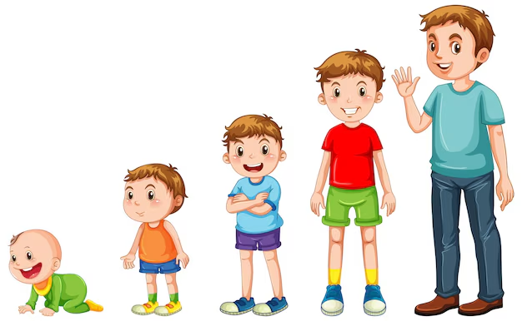  Why do we need to keep healthy?  - What do humans need to survive?  - What is a healthy diet?  - How do humans change as they grow into adults?  - Do we all grow the same?  - Do we need to exercise?  - Can we describe how to stay healthy and hygienic? | 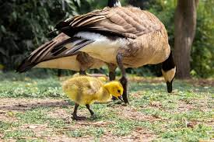  How do we know something is alive?  1. How do I know if something is alive, dead or never been alive?  2. How is new life made?  3. Do animal offspring look the same as their parents?  4. How do animals grow and change?  5. What is a lifecycle?  6. What do animals need to stay alive and how do we know if something is alive?

Curriculum Overview Lower KS2
Lower Key Stage 2 CYCLE 1
AUTUMN | SPRING | SUMMER
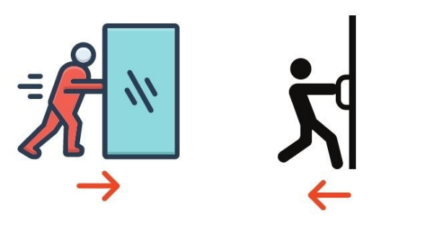  How do forces help us?  1. How do objects move on different surfaces?  2. Do forces need contact?  3. Do magnets always attract?  4. Which materials are magnetic?  5. How do forces help us? | 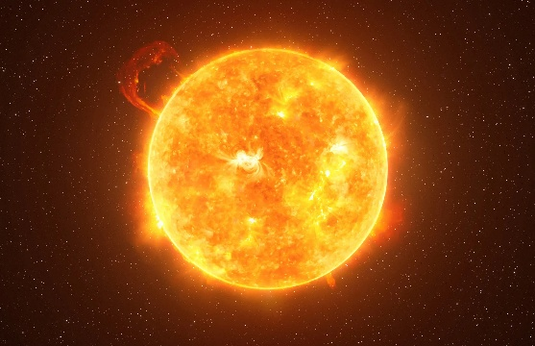  What if the sun didn’t shine?  1. What is a light source?  2. Which materials are reflective?  3. How are shadows formed?  4. How can I change the size of a shadow?  5. How can I stay safe in the sun?  6. What if the sun didn’t shine? | 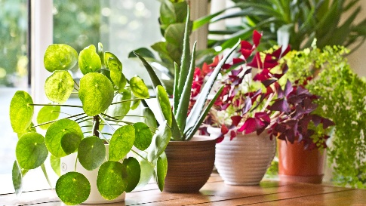  Do plants eat?  1. What do plants need to survive?  2. What are the parts of a plant?  TAPS assessment – Close observation of a flowering plant (year 3)  3. What are the functions of the different parts?  4. How do plants use and transport water?  5. What is the life cycle of a plant?  6. How do plants reproduce?
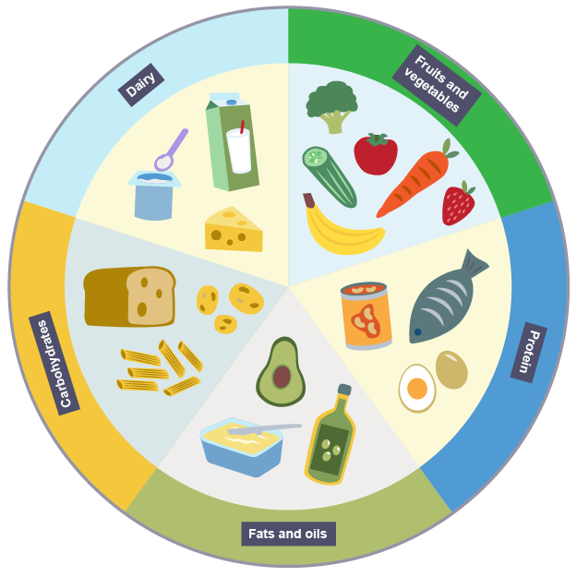  Are we what we eat?  1. Do humans make or find food?  2. What are the 5 key food groups?  3. What nutrition is in the food we eat?  4. Does it matter how much food I eat?  5. Are we what we eat? | 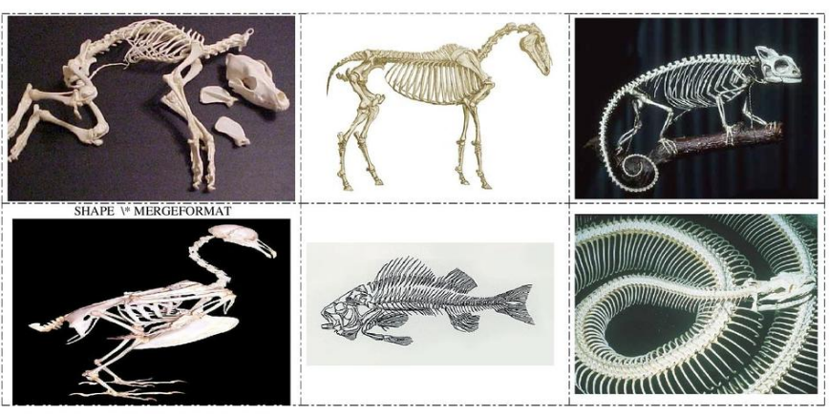  How do I stand and move?  1. What do skeletons do?  2. What are the different types of skeletons?  3. Which bones are in the human skeleton?  4. Which bones are in animal skeletons?  5. What roles do muscles play in moving?  6. How do I stand and move? | 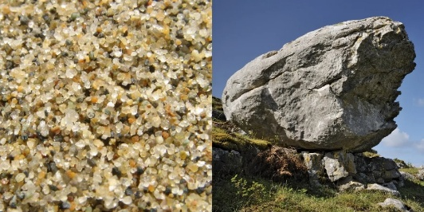  Do rocks talk to us?  1. What are rocks?  2. What are the different types of rocks?  3. What are the properties of different types of rock?  4. TAPs assessment  5. How are fossils formed?  6. What is soil?

Lower Key Stage 2 CYCLE 2
AUTUMN | SPRING | SUMMER
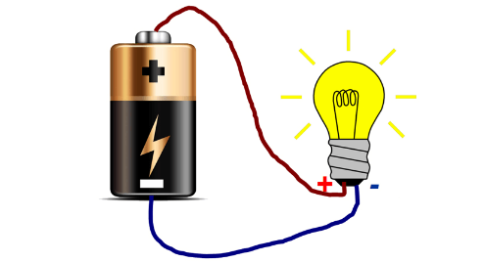  What happens when I turn a switch on?  - What is electricity?  - How can we make electricity safe?  - Good conductor, bad conductor?  Y3/4 - TAPS assessment – Does it conduct electricity?  - Can I solve an electrical problem?  - Y3/4 - How can I turn a lamp on and off?  - Y3/4 - Can I turn a door into an alarm? | 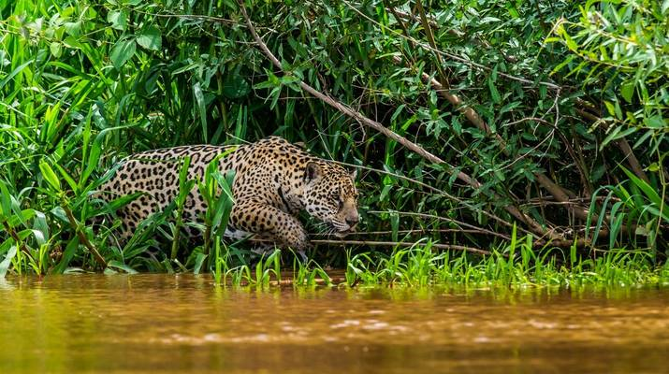  What animal am I most like?  - How well do I know the animals around me?  - How do life cycles differ between living things?  - Does reproduction always occur in the same way?  - What’s the point in ‘grouping’ or ‘classifying’ living things?  - What’s the best way to group (classify) the living things around me?  - How different are living things really? | 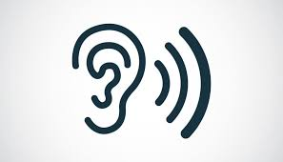  What is sound?  - How does sound travel?  - How do we hear things?  - How are different sounds made?  - Why do sounds have different pitch? TAPS assessment.  - Can you hear me?
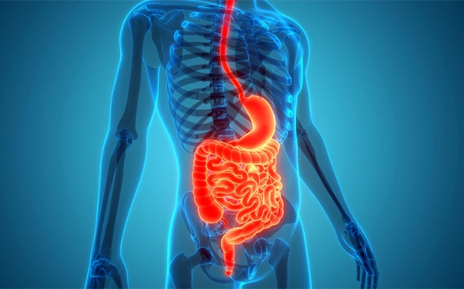  How many miles does my food travel?  - Are these your teeth?  - How can I keep my teeth healthy?  - What happens to my food?  - How many miles does my food travel? (TAPS assessment – Digestion modelling). | 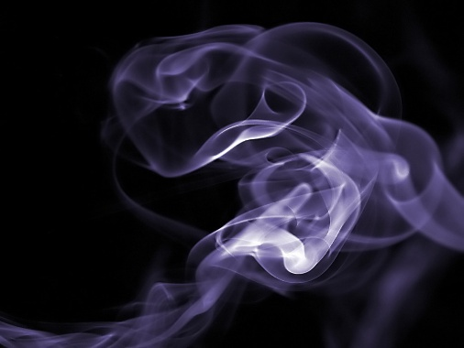  Why can’t I hold gases?  - What state am I?  - What is a particle?  - Can something be more than one state?  - Investigation. (heating and cooling)  - How does this affect our weather? (Water cycle) | 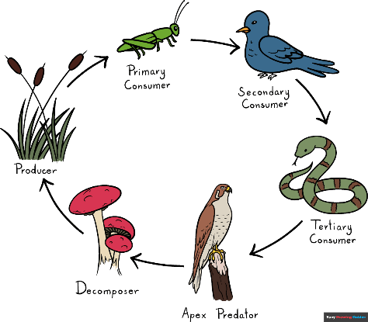  Who is at the top of the food chain?  - What is a food chain?  - What role do producers play in a food chain?  - What role do consumers play in a food chain?  - Can you describe predators and prey?  - Who is at the top of the food chain?

Curriculum Overview Upper KS2
Upper Key Stage 2 CYCLE 1
AUTUMN | SPRING | SUMMER
How do forces shape the way objects move and interact in our world?  1.What is gravity and how is the work of Sir Issac Newton important?  2.What is the connection between air resistance and parachutes?  3.Which factors affect air resistance?  4.What is the effect of friction on different surfaces?  5.Which forces act on objects and how can it be altered by levers and pulleys?  6.Which forces act on objects and how can it be altered by gears? | What if the sun didn’t shine?  1. What is a light source?  2. Which materials are reflective?  3. How are shadows formed?  4. How can I change the size of a shadow?  5. How can I stay safe in the sun?  6. What if the sun didn’t shine? | 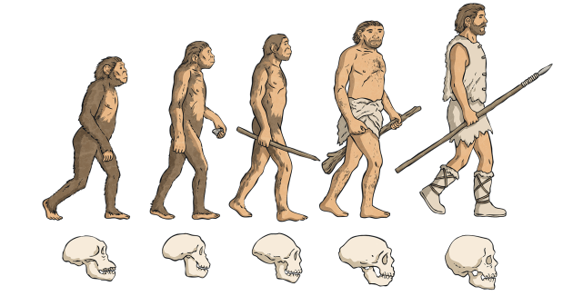  How has life changed over time?  1.How do offspring vary and which are not identical to their parents?  2.How do animals adapt to their environment and how do their adaptations help them to survive?  3.How are plants adapted to their environment and how do their adaptations help them to survive?  4.What can we learn from fossils?  5.What is the theory of evolution by natural selection?  6.How have humans evolved?
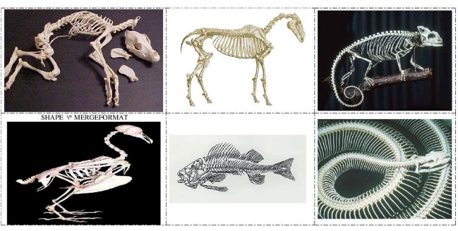  How do living things grow, change, and adapt, and how can we organise and understand the diversity of life?  1. What are the key stages of a mammal’s life cycle and what happens in each stage?  2.What is a gestation period and how does differ for different mammals?  3.What are the different the stages during foetal development?  5.What kind of changes do we experience during puberty?  6.What kind of changes do we experience during old age? | 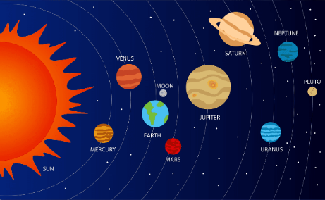  What makes our solar system so special and how does it affect life on Earth?  1. Can I name the order of the planets and recognise their characteristics?  2. Can I explain about the heliocentric nature of the solar system?  3. How does the Earth move around in space?  4. Can I explain how the Earth’s rotation gives us day and night?  5. Can I explain the movement of the moon and how the phases are created?  6. What makes our solar system so special and how does it affect life on Earth? | Do plants eat?  1. What do plants need to survive?  2. What are the functions of the different parts?  3. How do plants use and transport water?  4. What is the life cycle of a plant?  5. How do plants reproduce?  6. TAPS assessment – flower sampling (year 6)

Upper Key Stage 2 CYCLE 2
AUTUMN | SPRING | SUMMER
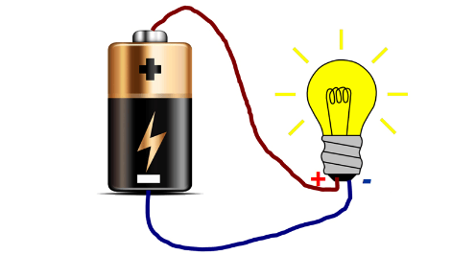  Do I have the power to control electricity?  1. What is electricity?  2. How can we make electricity safe?  3. Good conductor, bad conductor?  Y5/6 - TAPS assessment – Conductor dough  4. Can I solve an electrical problem?  5. Can I change the brightness of a lamp?  6. Can I affect how quickly a motor spins? | What animal am I most like?  - How well do I know the animals around me?  - How do life cycles differ between living things?  - Does reproduction always occur in the same way?  - What’s the point in ‘grouping’ or ‘classifying’ living things?  - What’s the best way to group (classify) the living things around me?  - How different are living things really? | What is sound?  - How does sound travel?  - How do we hear things?  - How are different sounds made?  - Why do sounds have different pitch?  - TAPS assessment.  - Can you hear me?
What is the function of the heart and its role in the circulatory system?  1.What are the different roles of the blood vessels?  2.What is the role of blood?  3.How does blood transport water and nutrients?  4.What can affect heart rate?  5.What are the effects of drugs and alcohol on the body? | 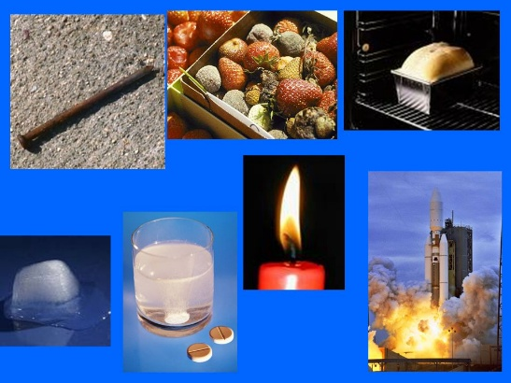  How can materials change?  1. How can I group materials?  2. Which materials are soluble?  3. How can I separate a solid from a liquid?  4. How can I separate a soluble solid from a solution?  5. What are reversible and irreversible changes?  6. How can materials change? | How can we protect animals in a food chain?  - What are the parts of a food chain?  - Can you make a food chain that we can find in our local area/  - How can food chains be presented?  - How do changes in the environment affect food chains?  - What threats are there to food chains?  - How can we protect animals in a food chain?

